Employee Wellness Analytics
Project Documentation | Power BI Dashboard
This document covers the Employee Wellness Analytics project: dataset format, data cleaning, the cleaned datasets, the data model, the report layout and the final dashboard snapshots. The solution helps the organisation analyse employee participation and engagement in wellness activities.
Item | Detail
Tool | Power BI Desktop (Power Query for cleaning, DAX for the Date table)
Source files | Employee Wellness Profile (CSV), Wellness Activities (CSV)
Model tables | Employee_Wellness_Profile, Wellness_Activities, Date
Contents | 1 Dataset Format | 2 Data Cleaning | 3 New Dataset After Cleaning | 4 Data Model & Relationships | 5 Report Layout | 6 Final Version Snapshot

1. Dataset Format
Two source datasets were loaded from CSV files. A third table, the Date Table, was created inside Power BI. Employee ID and Date are the linking fields.

1.1 Employee Wellness Profile
Demographic, organisational and wellness information of each employee (one row per employee).
Field | Data Type | Description
Employee ID | Whole Number | Unique identifier of each employee (key)
Employee Name | Text | Full name of the employee
Email | Text | Official employee email address
Department | Text | Department in which the employee works
Designation | Text | Current job role / designation
Wellness Goal | Text | Primary wellness objective (e.g. Fitness, Nutrition, Mindfulness)
Activity Level | Text | General activity level: Low, Moderate or High
Wellness Score | Decimal Number | Overall wellness score on a 0-100 scale
Enrollment Date | Date | Date the employee joined the wellness program
Status | Text | Program status: Active or Inactive

1.2 Wellness Activities
Wellness activities performed or planned by employees (one row per activity record).
Field | Data Type | Description
Activity ID | Whole Number | Unique identifier of each activity record (key)
Employee ID | Whole Number | Links the activity to an employee (foreign key)
Activity Name | Text | Name of the activity (e.g. Meditation, Health Workshop)
Activity Type | Text | Category: Fitness, Sports, Yoga, Meditation, Nutrition, Health Check
Activity Date | Date | Date the activity occurred or was scheduled
Duration (Minutes) | Whole Number | Duration of the activity in minutes
Calories Burned | Whole Number | Estimated calories burned
Participation Status | Text | Completed, Planned or Cancelled
Wellness Points | Whole Number | Points awarded for participation
Remarks | Text | Additional information about the activity

1.3 Date Table (created in Power BI)
A single central Date Table, created using DAX, provides the common time dimension. Fields: Date, Year, Month Number, Month, Month Short, Quarter, Year Month, Day, Day Name, Day Short, Day of Week.

2. Data Cleaning - What We Have Done
Both CSV files were imported using Get Data > Text/CSV > Transform Data, and cleaned in Power Query before the model was built.

2.1 Employee Wellness Profile
- Structure: Promoted headers, applied data types (Employee ID as Whole Number, Wellness Score as Decimal, Enrollment Date as Date) and removed error rows.  - Text cleaning: Trim and Clean removed extra spaces and non-printing characters.  - Standardising: Capitalize Each Word for names and categories; Lowercase for email addresses.  - Categories: Replace Value fixed inconsistent categories, e.g. it to IT, moderate to Moderate, LOW to Low, Stress management to Stress Management, active to Active.  - Missing values: Missing Wellness Score kept as null, not 0, so it is not read as a real score of zero.  - Dates: Enrollment Date converted to Date; mixed formats handled with Using Locale.  - Appended data: Additional employee records were added using Append Queries (last applied step). | 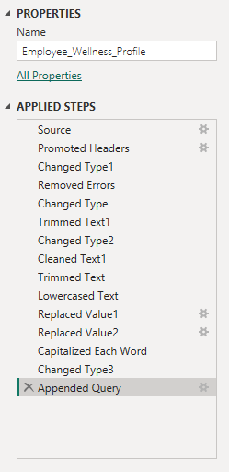  Applied steps in Power Query

2.2 Wellness Activities
Area | Cleaning performed
Data types | IDs, Duration, Calories and Points set to Whole Number; Activity Date set to Date.
Text cleaning | Trimmed and cleaned text; standardised Activity Name, Activity Type, Participation Status and Remarks (e.g. morning walk to Morning Walk, fitness to Fitness, completed to Completed).
Date cleaning | Mixed date formats converted to Date using locale settings to read day/month/year correctly.
Duration | Inconsistent entries such as "20 mins" fixed by extracting the numeric part and converting to Whole Number.
Missing values | Missing Calories Burned kept as null (not 0) to separate "not recorded" from "zero calories".
Participation Status | Standardised to Completed, Planned and Cancelled. Cancelled rows kept for future cancellation-rate analysis.

2.3 Columns added and quality checks
- Completed Flag: conditional column from Participation Status: Completed = 1, Planned = 0, Cancelled = 0. Makes counting completed activities simple in measures.
- Calories Recorded Flag: indicates whether calorie data is available; used to check data completeness.
- Quality checks: duplicate and missing Employee IDs checked; Employee IDs verified as consistent keys across both tables; categorical values verified as standardised.

3. New Dataset After Cleaning
After cleaning, the model contains three analysis-ready tables.
Table | Role | State after cleaning
Employee_Wellness_Profile | Dimension (1 side) | Unique Employee IDs; consistent Department, Wellness Goal, Activity Level and Status values; lowercase emails; Wellness Score as decimal; Enrollment Date as Date.
Wellness_Activities | Fact (many side) | Standardised names, types and status; valid Activity Dates; numeric Duration; Completed Flag added; nulls preserved where data is missing.
Date | Dimension (1 side) | Created in DAX and marked as date table; Month sorted by Month Number and Day Name by Day of Week.

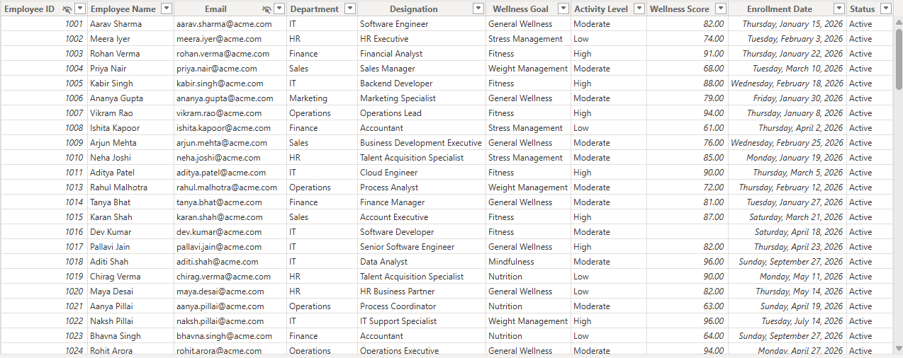
Figure 1: Employee_Wellness_Profile after cleaning
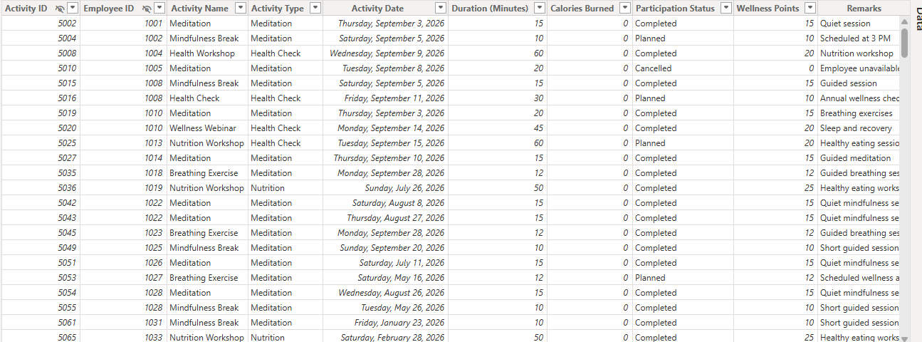
Figure 2: Wellness_Activities after cleaning

4. Data Model Building & Relationships
The final model follows a simple star schema: the Wellness Activities fact table sits in the centre, filtered by the Employee Wellness Profile and Date dimensions.
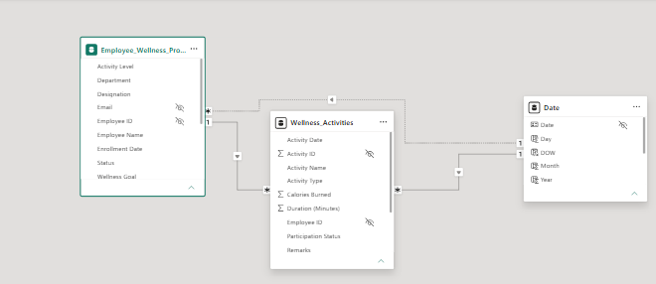
Figure 3: Model view
Relationship (From to To) | Cardinality | Filter | Status / Purpose
Employee_Wellness_Profile[Employee ID] to Wellness_Activities[Employee ID] | One-to-Many | Single | Active. Employee details filter their activities.
Date[Date] to Wellness_Activities[Activity Date] | One-to-Many | Single | Active. Time-based analysis on activity date.
Date[Date] to Employee_Wellness_Profile[Enrollment Date] | One-to-Many | Single | Inactive. Available for enrollment-date analysis via USERELATIONSHIP.

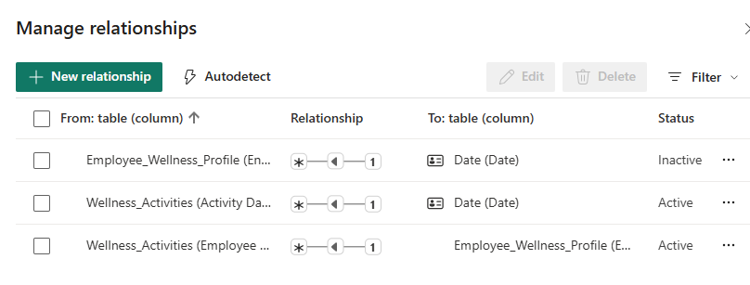
Figure 4: Manage relationships
A Department > Designation hierarchy was also created in the profile table to allow drill-down in the dashboard.

5. Report Layout
The report has two pages. A logo and slicers sit at the top-left of each page, with the charts arranged in a grid of 2-3 visuals beside and below them.

Page 1 - Overview
Visual | Type | Fields / Purpose
Month | Slicer (dropdown) | Filters the whole page by month
Average Wellness Score by Department | Column chart | Department vs average Wellness Score
Average Activity Duration by Activity Type | Donut chart | Share of average duration across Sports, Fitness, Nutrition, Health Check, Yoga, Meditation
Sum of Duration and Wellness Points by Year and Month | Line chart | Monthly trend of total minutes and points

Page 2 - Wellness Analysis
Visual | Type | Fields / Purpose
Department, Designation | Hierarchy slicer | Drill from Department down to Designation
Average Wellness Score and Average Activity Duration by Department | KPI card with trend | Headline average wellness score (79.93) against a goal
Average Wellness Score by Activity Level | Column chart | Compares High, Moderate and Low activity levels
Average Wellness Score by Department and Wellness Goal | Clustered column | Compares goals within each department

6. Final Version Snapshot
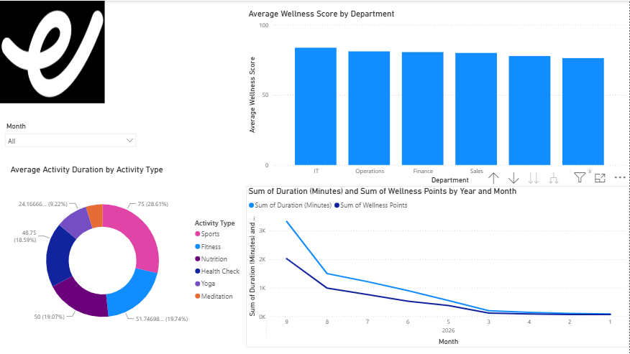
Figure 5: Dashboard Page 1 - Overview
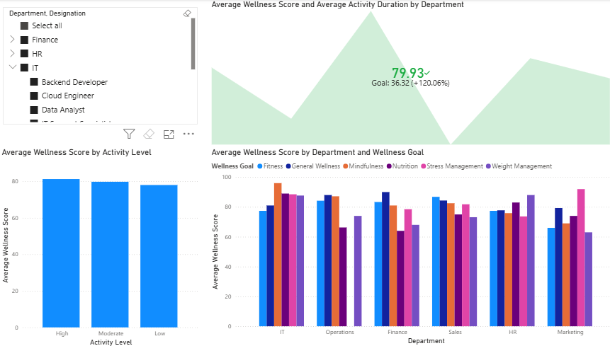
Figure 6: Dashboard Page 2 - Wellness Analysis

Outcome
The cleaned model supports analysis of wellness participation, completed vs planned activities, wellness points, activity types and duration, calories recorded, monthly trends, department-level participation and overall employee engagement.

